WebAPI
Exercise 5
- Code
Kafka/KafkaProducer.cs
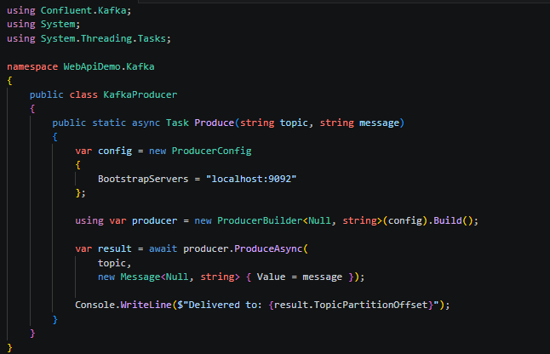

Kafka/KafkaConsumer.cs
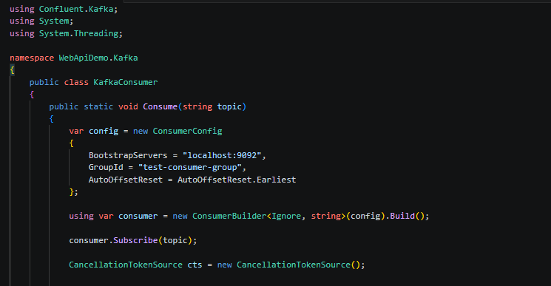

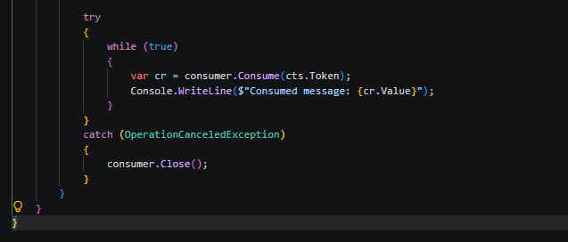

- Output
Producer


Consumer


